 | Nitte Meenakshi Institute of Technology  (AN AUTONOMOUS INSTITUTION, AFFILIATED TO VISVESVARAYA TECHNOLOGICAL UNIVERSITY, BELGAUM) , (A Unit of Nitte Education Trust, Mangalore)  PB No. 6429, Yelahanka, Bangalore 560-064, Karnataka  Telephone: 080- 22167860, Fax: 080 – 22167805  Department of Computer Science and Engineering | 
Date: 03-05-2017
ANDROID LABORATORY - PROGRAMS
Code: 14CSL77
PART – A

- In this lab we will be learning how to use and extend the Android user interface library.
  - Views, View Groups, Layouts, and Widgets are and how they relate to each other.
  - How to declare and reference resources in code.
  - How to navigate between multiple activities.
  - How to share the data between the activities.
  - Explore life-cycle methods of an activity.
  - How to use Events and Event Listeners.
  - How to create Toast Notifications.

a,b,c:
Application to raise a toast mesg on button click and to navigate from one page to another using intents
LoginActivity.java
package com.nmit.kavyaapplication;
import android.app.Activity;
import android.content.Intent;
import android.os.Bundle;
import android.view.View;
import android.widget.Button;
import android.widget.EditText;
import android.widget.EditText;
import android.widget.TextView;
import android.widget.Toast;
import com.nmit.kavyaapplication.RegisterActivity;
public class LoginActivity extends Activity implements View.OnClickListener {
Button btnSubmit;
Button btnReg;
EditText usrname;
EditText pwd;
@Override
protected void onCreate(Bundle savedInstanceState) {
super.onCreate(savedInstanceState);
setContentView(R.layout.activity_login);
//initialize view components
btnSubmit = (Button) findViewById(R.id.btnSubmit);
btnReg = (Button) findViewById(R.id.btnReg);
usrname = (EditText) findViewById(R.id.usrname);
pwd = (EditText) findViewById(R.id.pwd);
//implements onclick event listener
btnSubmit.setOnClickListener(LoginActivity.this);
btnReg.setOnClickListener(LoginActivity.this);
}
@Override
public void onClick(View v) {
switch (v.getId())
{
case R.id.btnSubmit:
Toast.makeText(LoginActivity.this,"success",Toast.LENGTH_SHORT).show();
break;
case R.id.btnReg:
Intent intent = new Intent(LoginActivity.this, RegisterActivity.class);
startActivity(new Intent(LoginActivity.this,RegisterActivity.class));
break;
}
}
}

RegisterActivity.java
package com.nmit.kavyaapplication;
import android.app.Activity;
import android.content.Intent;
import android.os.Bundle;
import android.support.annotation.Nullable;
import android.view.View;
import android.widget.Button;
import android.widget.EditText;
import android.widget.EditText;
import android.widget.TextView;
import android.widget.Toast;
public class RegisterActivity extends Activity{
@Override
protected void onCreate(Bundle savedInstanceState){
super.onCreate(savedInstanceState);
setContentView(R.layout.activity_register);
}
}

activity_login.xml
<?xml version="1.0" encoding="utf-8"?>
<RelativeLayout xmlns:android="http://schemas.android.com/apk/res/android"
xmlns:tools="http://schemas.android.com/tools"
android:id="@+id/activity_login"
android:layout_width="match_parent"
android:layout_height="match_parent"
android:background="@color/colorAccent"
>
<Button
android:layout_width="wrap_content"
android:layout_height="wrap_content"
android:id="@+id/btnReg"
/>
<EditText
android:layout_width="wrap_content"
android:layout_height="wrap_content"
android:id="@+id/etusrname"
/>
<EditText
android:layout_width="wrap_content"
android:layout_height="wrap_content"
android:id="@+id/etpwd"
android:hint="enter passwrd"
android:inputType="numberPassword"
android:textColor="@color/colorPrimaryDark"
android:layout_marginTop="25dp"
/>
<Button
android:layout_width="wrap_content"
android:layout_height="wrap_content"
android:id="@+id/btnSubmit"
android:text="@string/submit"
android:layout_marginTop="40dp" />
</RelativeLayout>

Activity_register.xml
<?xml version="1.0" encoding="utf-8"?>
<LinearLayout xmlns:android="http://schemas.android.com/apk/res/android"
android:orientation="vertical" android:layout_width="match_parent"
android:layout_height="match_parent"
android:background="@color/colorPrimaryDark">
<EditText
android:layout_width="wrap_content"
android:layout_height="wrap_content"
android:id="@+id/name"
android:hint="enter ur name"
/>
<EditText
android:layout_width="wrap_content"
android:layout_height="wrap_content"
android:id="@+id/pswd"
android:hint="enter ur pin"
android:textColor="@color/colorAccent"/>
<EditText
android:layout_width="wrap_content"
android:layout_height="wrap_content"
android:id="@+id/confirm"
android:hint="confirm ur pin"
android:textColor="@color/colorAccent"/>
<EditText
android:layout_width="wrap_content"
android:layout_height="wrap_content"
android:id="@+id/email"
android:hint="enter ur email id"
android:textColor="@color/colorAccent"/>
<EditText
android:layout_width="wrap_content"
android:layout_height="wrap_content"
android:id="@+id/phno"
android:hint="enter ur phoneno"
android:textColor="@color/colorAccent"/>
<Button
android:layout_width="wrap_content"
android:layout_height="wrap_content"
android:id="@+id/btnok"
android:text="OK"
android:textColor="@color/colorPrimaryDark"/>
</LinearLayout>

Androidmanifest.xml
<?xml version="1.0" encoding="utf-8"?>
<manifest xmlns:android="http://schemas.android.com/apk/res/android"
package="com.nmit.kavyaapplication">
<application
android:allowBackup="true"
android:icon="@mipmap/ic_launcher"
android:label="@string/app_name"
android:supportsRtl="true"
android:theme="@style/AppTheme">
<activity android:name=".LoginActivity">
<intent-filter>
<action android:name="android.intent.action.MAIN" />
<category android:name="android.intent.category.LAUNCHER" />
</intent-filter>
</activity>
<activity android:name=".RegisterActivity">
</activity>
</application>
</manifest>

d. How to share the data between the activities.
passing data between intents

first xml
------------------------
<?xml version="1.0" encoding="utf-8"?>
<RelativeLayout xmlns:android="http://schemas.android.com/apk/res/android"
xmlns:tools="http://schemas.android.com/tools"
android:id="@+id/activity_main"
android:layout_width="match_parent"
android:layout_height="match_parent"
android:paddingBottom="@dimen/activity_vertical_margin"
android:paddingLeft="@dimen/activity_horizontal_margin"
android:paddingRight="@dimen/activity_horizontal_margin"
android:paddingTop="@dimen/activity_vertical_margin"
tools:context="com.example.user.suppass.MainActivity">

<TextView
android:layout_width="wrap_content"
android:layout_height="wrap_content"
android:text="Hello World!" />

<EditText

android:id="@+id/etName"
android:layout_width="wrap_content"
android:layout_height="wrap_content"
android:text="Enter username"
android:layout_marginTop="50dp"/>
<Button
android:id="@+id/btnSubmit"
android:layout_width="wrap_content"
android:layout_height="wrap_content"
android:text="Submit"
android:layout_marginTop="100dp"/>

</RelativeLayout>
-----------------------------------------------------------------------
first . java class
package com.example.user.suppass;

import android.content.Intent;
import android.support.v7.app.AppCompatActivity;
import android.os.Bundle;
import android.view.View;
import android.widget.Button;
import android.widget.EditText;
import android.widget.Toast;

public class MainActivity extends AppCompatActivity implements View.OnClickListener {
Button btnSubmit;
EditText etName;
@Override
protected void onCreate(Bundle savedInstanceState) {
super.onCreate(savedInstanceState);
setContentView(R.layout.activity_main);

btnSubmit= (Button) findViewById(R.id.btnSubmit);
etName = (EditText) findViewById(R.id.etName);

btnSubmit.setOnClickListener(MainActivity.this);
}

@Override
public void onClick(View v) {
Intent in = new Intent(MainActivity.this, Main2Activity.class);
in.putExtra("UserName",etName.getText().toString() );
startActivity(in);

}
}
---------------------------------------------------------------------------------------------

second . xml
---------------
<?xml version="1.0" encoding="utf-8"?>
<RelativeLayout xmlns:android="http://schemas.android.com/apk/res/android"
xmlns:tools="http://schemas.android.com/tools"
android:id="@+id/activity_main2"
android:layout_width="match_parent"
android:layout_height="match_parent"
android:paddingBottom="@dimen/activity_vertical_margin"
android:paddingLeft="@dimen/activity_horizontal_margin"
android:paddingRight="@dimen/activity_horizontal_margin"
android:paddingTop="@dimen/activity_vertical_margin"
tools:context="com.example.user.suppass.Main2Activity">

<EditText
android:id="@+id/etDisplay"
android:layout_width="wrap_content"
android:layout_height="wrap_content"
android:text="Username"/>

</RelativeLayout>
------------------------------------------------------------------------------------
second . java
---------------------

import android.support.v7.app.AppCompatActivity;
import android.os.Bundle;
import android.widget.EditText;

public class Main2Activity extends AppCompatActivity {
EditText etDisplay;
@Override
protected void onCreate(Bundle savedInstanceState) {
super.onCreate(savedInstanceState);
setContentView(R.layout.activity_main2);

etDisplay= (EditText) findViewById(R.id.etDisplay);
etDisplay.setText(getIntent().getExtras().getString("UserName"));

}
}
-----------------------------------------------------------------------------------------------
Manifest.xml
------------------
<?xml version="1.0" encoding="utf-8"?>
<manifest xmlns:android="http://schemas.android.com/apk/res/android"
package="com.example.user.suppass">

<application
android:allowBackup="true"
android:icon="@mipmap/ic_launcher"
android:label="@string/app_name"
android:supportsRtl="true"
android:theme="@style/AppTheme">
<activity android:name=".MainActivity">
<intent-filter>
<action android:name="android.intent.action.MAIN" />

<category android:name="android.intent.category.LAUNCHER" />
</intent-filter>
</activity>
<activity android:name=".Main2Activity"></activity>
</application>

</manifest>

#demo on activity lifecycle

#java class-mainactivity
package com.nmit.lifecycle;

import android.support.v7.app.AppCompatActivity;
import android.os.Bundle;
import android.util.Log;

public class MainActivity extends AppCompatActivity {
private static final String Tag=MainActivity.class.getSimpleName();

@Override
protected void onCreate(Bundle savedInstanceState) {
super.onCreate(savedInstanceState);
setContentView(R.layout.activity_main);
Log.i(Tag,"in method onCreate");

}

@Override
protected void onStart() {
super.onStart();
Log.i(Tag,"in method onStart");
}

@Override
protected void onResume() {
super.onResume();
Log.i(Tag,"in method onResume");
}

@Override
protected void onPause() {
super.onPause();
Log.i(Tag,"in method onPause");
}

@Override
protected void onStop() {
super.onStop();
Log.i(Tag,"in method onStop");
}

@Override
protected void onDestroy() {
super.onDestroy();
Log.i(Tag,"in method onDestroy");
}
}
#xml file
<?xml version="1.0" encoding="utf-8"?>
<RelativeLayout xmlns:android="http://schemas.android.com/apk/res/android"
xmlns:tools="http://schemas.android.com/tools"
android:id="@+id/activity_main"
android:layout_width="match_parent"
android:layout_height="match_parent"
android:paddingBottom="@dimen/activity_vertical_margin"
android:paddingLeft="@dimen/activity_horizontal_margin"
android:paddingRight="@dimen/activity_horizontal_margin"
android:paddingTop="@dimen/activity_vertical_margin"
tools:context="com.nmit.lifecycle.MainActivity">

<TextView
android:layout_width="wrap_content"
android:layout_height="wrap_content"
android:text="Hello World!" />
</RelativeLayout>

- You will expand on your knowledge of the Android user interface library.
  - How to declare layouts statically as an xml resource.
  - How to create custom Views from scratch to suit a specific need.
  - How to create Options and Context Menus.
  - How to use ListAdapter and ArrayAdapter to bind data source to a List View.
  - How to create AlertDialog and progress Dialog in your activity.

- Android-app-java-res-layout resource or drawable resource-Rtclick-new-file

- CUSTOM VIEW DEMO PROGRAM
Activity_main.xml
<?xml version="1.0" encoding="utf-8"?>
<RelativeLayout xmlns:android="http://schemas.android.com/apk/res/android"
xmlns:tools="http://schemas.android.com/tools"
android:id="@+id/activity_main"
android:layout_width="match_parent"
android:layout_height="match_parent"
android:paddingBottom="@dimen/activity_vertical_margin"
android:paddingLeft="@dimen/activity_horizontal_margin"
android:paddingRight="@dimen/activity_horizontal_margin"
android:paddingTop="@dimen/activity_vertical_margin"
tools:context="com.example.user.mycustomapp.MainActivity">
<com.example.user.mycustomapp.Views.CustomView
android:layout_width="match_parent"
android:layout_height="150dp"
android:id="@+id/CustomView"/>
<TextView
android:layout_width="wrap_content"
android:layout_height="wrap_content"
android:text="This is a CUSTOM VIEW DEMO!"
android:textColor="@color/colorAccent"/>
<Button
android:layout_width="wrap_content"
android:layout_height="wrap_content"
android:id="@+id/btnswapcolor"
android:text="SWAP COLOR"
android:layout_marginTop="300dp"/>
</RelativeLayout>

CUSTOMVIEW.JAVA

package com.example.user.mycustomapp.Views;
import android.content.Context;
import android.graphics.Canvas;
import android.graphics.Color;
import android.graphics.Paint;
import android.graphics.Rect;
import android.support.annotation.Nullable;
import android.util.AttributeSet;
import android.view.View;
/**
* Created by user on 8/14/2018.
*/
public class CustomView extends View {
private static final int SQUARE_SIZE=200;
private Rect mRectSquare;
private Paint mPaintSquare;
public CustomView(Context context) {
super(context);
init(null);
}
public CustomView(Context context, AttributeSet attrs) {
super(context, attrs);
init(attrs);
}
public CustomView(Context context, AttributeSet attrs, int defStyleAttr) {
super(context, attrs, defStyleAttr);
init(attrs);
}
public CustomView(Context context, AttributeSet attrs, int defStyleAttr, int defStyleRes) {
super(context, attrs, defStyleAttr, defStyleRes);
init(attrs);
}
` public void SwapColor()
{
mPaintSquare.setColor(mPaintSquare.getColor()==Color.GREEN?Color.RED:Color.GREEN);
postInvalidate();
}
private void init(@Nullable AttributeSet set) {
mRectSquare=new Rect();
mPaintSquare=new Paint(Paint.ANTI_ALIAS_FLAG);
mPaintSquare.setColor(Color.GREEN);
}
@Override
protected void onDraw(Canvas canvas)
{
Rect rect=new Rect();
mRectSquare.left=50;
mRectSquare.top=50;
mRectSquare.right=mRectSquare.left+SQUARE_SIZE;
mRectSquare.bottom=mRectSquare.top+SQUARE_SIZE;
canvas.drawRect(mRectSquare,mPaintSquare);
}
}

MAINACTIVITY.JAVA

package com.example.user.mycustomapp;
import android.support.v7.app.AppCompatActivity;
import android.os.Bundle;
import android.view.View;
import com.example.user.mycustomapp.Views.CustomView;
public class MainActivity extends AppCompatActivity {
private CustomView mCustomView;
@Override
protected void onCreate(Bundle savedInstanceState) {
super.onCreate(savedInstanceState);
setContentView(R.layout.activity_main);
mCustomView=(CustomView)findViewById(R.id.CustomView);
findViewById(R.id.btnswapcolor).setOnClickListener(new View.OnClickListener()
{
@Override
public void onClick(View V)
{
mCustomView.SwapColor();
}
});
}
}

OUTPUT

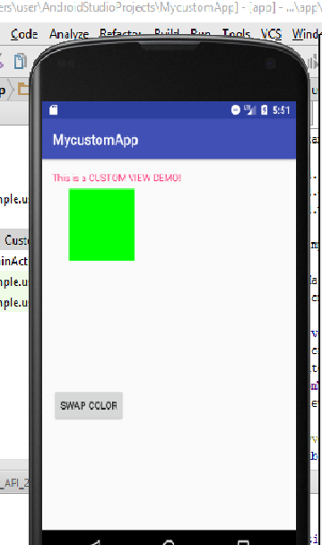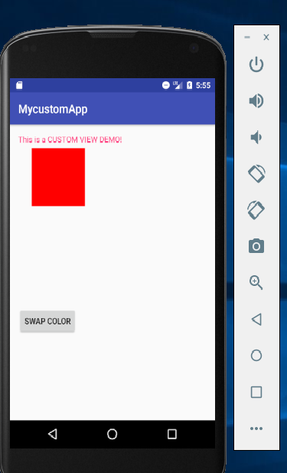

- How to create Options and Context Menus.

Demo program on Option Menu
How to create menu xml?
Goto java tab-select your package-rt clk-new-android resource file
Give file name(my_menu) and select resource type as menu and save

My_menu.xml
<?xml version="1.0" encoding="utf-8"?>
<menu xmlns:android="http://schemas.android.com/apk/res/android">
<item android:id="@+id/item1"
android:title="option 1"/>
<item android:id="@+id/item2"
android:title="option 2"/>
<item android:id="@+id/item3"
android:title="option 3"/>
</menu>

MainActivity.Java
package nmit.optionmenu;
import android.support.v7.app.AppCompatActivity;
import android.os.Bundle;
import android.view.Menu;
import android.view.MenuInflater;
import android.view.MenuItem;
import android.widget.Toast;
public class MainActivity extends AppCompatActivity {
@Override
protected void onCreate(Bundle savedInstanceState) {
super.onCreate(savedInstanceState);
setContentView(R.layout.activity_main);
}
@Override
public boolean onCreateOptionsMenu(Menu menu)
{
MenuInflater menuInflater=getMenuInflater();
menuInflater.inflate(R.menu.my_menu,menu);
return super.onCreateOptionsMenu(menu);
}
@Override
public boolean onOptionsItemSelected(MenuItem item)
{
switch (item.getItemId()){
case R.id.item1:
Toast.makeText(this,"option 1 is selected",Toast.LENGTH_SHORT).show();
break;
case R.id.item2:
Toast.makeText(this,"option 2 is selected",Toast.LENGTH_SHORT).show();
break;
case R.id.item3:
Toast.makeText(this,"option 3 is selected",Toast.LENGTH_SHORT).show();
break;
}
return super.onOptionsItemSelected(item);
}
}

Activity_main.xml
<?xml version="1.0" encoding="utf-8"?>
<RelativeLayout xmlns:android="http://schemas.android.com/apk/res/android"
xmlns:tools="http://schemas.android.com/tools"
android:id="@+id/activity_main"
android:layout_width="match_parent"
android:layout_height="match_parent"
android:paddingBottom="@dimen/activity_vertical_margin"
android:paddingLeft="@dimen/activity_horizontal_margin"
android:paddingRight="@dimen/activity_horizontal_margin"
android:paddingTop="@dimen/activity_vertical_margin"
tools:context="nmit.optionmenu.MainActivity">
<TextView
android:layout_width="wrap_content"
android:layout_height="wrap_content"
android:text="DEMO PROGRAM ON OPTIONS MENU!"
android:textColor="@color/colorAccent"/>
</RelativeLayout>

Output:
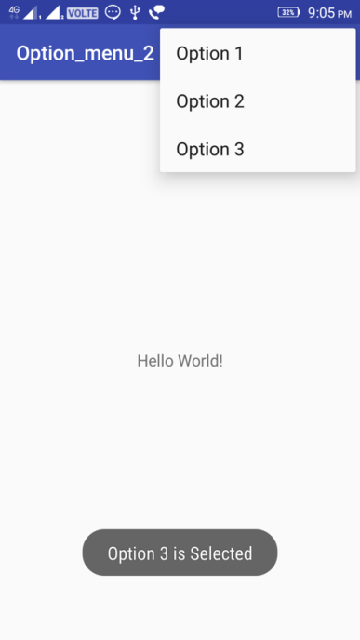

CONTEXT MENU
//XML FILE

<?xml version="1.0" encoding="utf-8"?>
<LinearLayout xmlns:android="http://schemas.android.com/apk/res/android"
xmlns:tools="http://schemas.android.com/tools"
android:id="@+id/activity_main"
android:orientation="vertical"
android:layout_width="match_parent"
android:layout_height="match_parent"
android:paddingBottom="@dimen/activity_vertical_margin"
android:paddingLeft="@dimen/activity_horizontal_margin"
android:paddingRight="@dimen/activity_horizontal_margin"
android:paddingTop="@dimen/activity_vertical_margin"
tools:context="nmit.mymenu.MainActivity">
<TextView
android:layout_width="wrap_content"
android:layout_height="wrap_content"
android:text="THIS IS A CONTEXT MENU DEMO"
android:textColor="@color/colorAccent"/>
<Button
android:id="@+id/btnShow"
android:layout_width="wrap_content"
android:layout_height="wrap_content"
android:text="Long press me"
android:layout_marginTop="200dp"
android:layout_marginLeft="100dp"/>
</LinearLayout>

//JAVA FILE
package nmit.mymenu;
import android.support.v7.app.AppCompatActivity;
import android.os.Bundle;
import android.view.ContextMenu;
import android.view.MenuItem;
import android.view.View;
import android.widget.Button;
import android.widget.Toast;
public class MainActivity extends AppCompatActivity {
@Override
protected void onCreate(Bundle savedInstanceState) {
super.onCreate(savedInstanceState);
setContentView(R.layout.activity_main);
Button btn = (Button) findViewById(R.id.btnShow);
registerForContextMenu(btn);
}
@Override
public void onCreateContextMenu(ContextMenu menu, View v, ContextMenu.ContextMenuInfo menuInfo) {
super.onCreateContextMenu(menu, v, menuInfo);
menu.setHeaderTitle("Context Menu");
menu.add(0, v.getId(), 0, "Upload");
menu.add(0, v.getId(), 3, "Search");
menu.add(0, v.getId(), 2, "Share");
menu.add(0, v.getId(), 1, "Bookmark");
}
@Override
public boolean onContextItemSelected(MenuItem item) {
Toast.makeText(this, "Selected Item: " +item.getTitle(), Toast.LENGTH_SHORT).show();
return true;
}
}
//OUTPUT
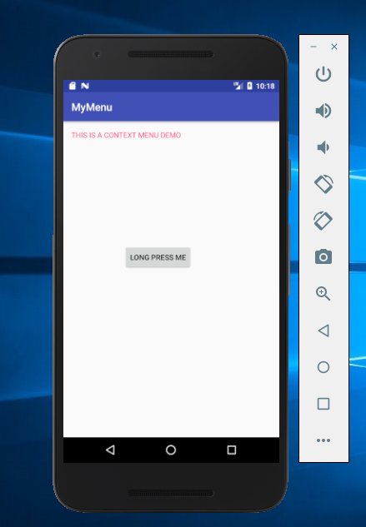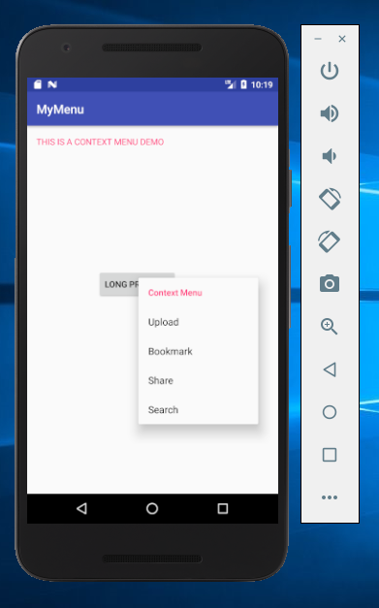

d. How to use ListAdapter and ArrayAdapter to bind data source to a List View.

ListView should have a TextView for array adapter to operate.

activity_main.xml (ListView widget)
....................................
?xml version="1.0" encoding="utf-8"?>
<LinearLayout xmlns:android="http://schemas.android.com/apk/res/android"
xmlns:tools="http://schemas.android.com/tools"
android:id="@+id/activity_main"
android:layout_width="match_parent"
android:layout_height="match_parent"
android:paddingBottom="@dimen/activity_vertical_margin"
android:paddingLeft="@dimen/activity_horizontal_margin"
android:paddingRight="@dimen/activity_horizontal_margin"
android:paddingTop="@dimen/activity_vertical_margin"
tools:context="nmit.listadapter.MainActivity">

<ListView
android:id="@+id/simpleListView"
android:layout_width="match_parent"
android:layout_height="wrap_content"
/>
</LinearLayout>

activity_listView.xml
.....................................
<?xml version="1.0" encoding="utf-8"?>
<LinearLayout xmlns:android="http://schemas.android.com/apk/res/android"
android:layout_width="match_parent"
android:layout_height="match_parent"
android:orientation="vertical">

<TextView
android:id="@+id/textView"
android:layout_width="fill_parent"
android:layout_height="wrap_content"
android:layout_gravity="center"
android:padding="@dimen/activity_horizontal_margin"
android:textColor="#000" />
</LinearLayout>

MainActivity.java
.................................
package nmit.listadapter;

import android.support.v7.app.AppCompatActivity;
import android.os.Bundle;
import android.widget.ArrayAdapter;
import android.widget.ListView;

public class MainActivity extends AppCompatActivity {
// Array of strings...
ListView simpleList;
String animalList[] = {"Lion","Tiger","Monkey","Elephant","Dog","Cat","Camel"};
@Override
protected void onCreate(Bundle savedInstanceState) {
super.onCreate(savedInstanceState);
setContentView(R.layout.activity_main);
simpleList = (ListView) findViewById(R.id.simpleListView);

ArrayAdapter<String> arrayAdapter = new ArrayAdapter<String>(this, R.layout.activity_listview, R.id.textView, animalList);
simpleList.setAdapter(arrayAdapter);
}

}

OUTPUT:
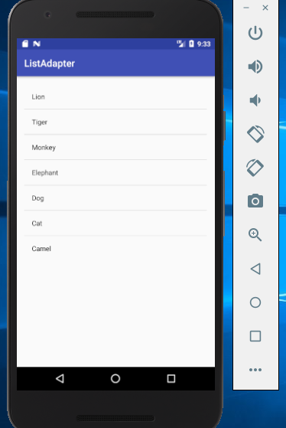

e.How to create AlertDialog and progress Dialog in your activity
Alert Dialog
package com.nmit.dialog;
import android.content.DialogInterface;
import android.support.v7.app.AlertDialog;
import android.support.v7.app.AppCompatActivity;
import android.os.Bundle;
import android.support.v7.widget.VectorEnabledTintResources;
import android.view.View;
import android.widget.Button;

public class MainActivity extends AppCompatActivity implements View.OnClickListener {

private static Button button_sbm;

@Override
protected void onCreate(Bundle savedInstanceState) {
super.onCreate(savedInstanceState);
setContentView(R.layout.activity_main);
button_sbm = (Button) findViewById(R.id.button);
button_sbm.setOnClickListener(MainActivity.this);
}

@Override
public void onClick(View v) {
AlertDialog.Builder a_builder = new AlertDialog.Builder(MainActivity.this);
a_builder. setMessage("Do you want to close this app!!!").setCancelable(false)
. setPositiveButton("yes", new DialogInterface.OnClickListener() {
@Override
public void onClick(DialogInterface dialog, int which) {
finish();
}
})
.setNegativeButton("No", new DialogInterface.OnClickListener() {
@Override
public void onClick(DialogInterface dialog, int which) {
dialog.cancel();
}
});
AlertDialog alert = a_builder.create();
alert.setTitle("ALERT!!");
alert.show();

}
}

//xml create a single button
<Button

android:text="Alert"
android:layout_width="wrap_content"
android:layout_height="wrap_content"

android:layout_marginTop="76dp"
android:id="@+id/button" />

Progress Dialog
package com.nmit.dialog;

import android.app.ProgressDialog;
import android.content.DialogInterface;
import android.support.v7.app.AlertDialog;
import android.support.v7.app.AppCompatActivity;
import android.os.Bundle;
import android.support.v7.widget.VectorEnabledTintResources;
import android.view.View;
import android.widget.Button;
import android.widget.Toast;

public class MainActivity extends AppCompatActivity implements View.OnClickListener {

private static Button btn;

@Override
protected void onCreate(Bundle savedInstanceState) {
super.onCreate(savedInstanceState);
setContentView(R.layout.activity_main);
btn = (Button) findViewById(R.id.progress);
btn.setOnClickListener(MainActivity.this);
}

@Override
public void onClick(View v) {
final ProgressDialog pd = new ProgressDialog(MainActivity.this);
pd.setTitle("Download");
pd.setMessage("Downloading....");
pd.setProgressStyle(pd.STYLE_HORIZONTAL);
pd.setProgress(0);
pd.setMax(100);

Thread t = new Thread(new Runnable() {
@Override
public void run() {
int progress = 0;
while(progress <=100){
try{
pd.setProgress(progress);
progress++;
Thread.sleep(200);
}catch(Exception ex) {

}
}
pd.dismiss();
MainActivity.this.runOnUiThread(new Runnable() {
@Override
public void run() {
Toast.makeText(MainActivity.this, "Download completed", Toast.LENGTH_SHORT).show();
}
});
}
});
t.start();
pd.show();
}
}

//xml create a single button
<Button

android:text="Progress"
android:layout_width="wrap_content"
android:layout_height="wrap_content"

android:layout_marginTop="76dp"
android:id="@+id/btn" />

OUTPUT:

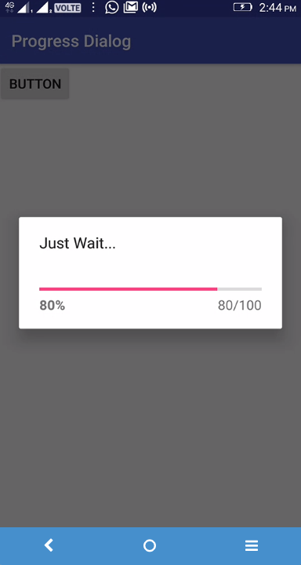
3.You will be persisting data using an SQLite Database and preserving the state of an application during its lifecycle.
  - How to save & restore data as Application Preferences (Shared Preference).
  - How to save & restore data as Instance State.
  - How to create and manage an SQLiteDatabase in Android.
  - How to insert, update, remove, and retrieve data from an SQLite Database.
  - Display data using RecyclerView.

- How to save & restore data as Application Preferences (Shared Preference).

Activity_main.xml
<?xml version="1.0" encoding="utf-8"?>
<RelativeLayout xmlns:android="http://schemas.android.com/apk/res/android"
xmlns:tools="http://schemas.android.com/tools"
android:id="@+id/activity_main"
android:layout_width="match_parent"
android:layout_height="match_parent"
android:paddingBottom="@dimen/activity_vertical_margin"
android:paddingLeft="@dimen/activity_horizontal_margin"
android:paddingRight="@dimen/activity_horizontal_margin"
android:paddingTop="@dimen/activity_vertical_margin"
tools:context="nmit.sharedpreference.MainActivity">
<TextView
android:layout_width="wrap_content"
android:layout_height="wrap_content"
android:text="DEMO PROGRAM ON SHARED PREFERENCES"
android:textColor="@color/colorAccent"/>
<EditText
android:layout_width="match_parent"
android:layout_height="wrap_content"
android:layout_marginTop="30dp"
android:background="@color/colorPrimary"
android:textColor="#FFFFFF"
android:id="@+id/name"
/>
<Button
android:layout_width="wrap_content"
android:layout_height="wrap_content"
android:layout_marginTop="80dp"
android:id="@+id/save"
android:text="SAVE"
android:onClick="sav"
/>
<Button
android:layout_width="wrap_content"
android:layout_height="wrap_content"
android:layout_marginTop="80dp"
android:layout_marginLeft="120dp"
android:id="@+id/delete"
android:text="DELETE"
android:onClick="del"
/>
<Button
android:layout_width="wrap_content"
android:layout_height="wrap_content"
android:layout_marginTop="80dp"
android:layout_marginLeft="220dp"
android:text="RETRIEVE"
android:id="@+id/retrieve"
android:onClick="ret"
/>
</RelativeLayout>
MainActivity.Java
package nmit.sharedpreference;
import android.content.Context;
import android.content.SharedPreferences;
import android.support.v7.app.AppCompatActivity;
import android.os.Bundle;
import android.view.View;
import android.widget.EditText;
public class MainActivity extends AppCompatActivity {
SharedPreferences sf;
EditText name;
public static final String preference="pref";
public static final String saveit="savekey";
@Override
protected void onCreate(Bundle savedInstanceState) {
super.onCreate(savedInstanceState);
setContentView(R.layout.activity_main);
name= (EditText) findViewById(R.id.name);
sf=getSharedPreferences(preference, Context.MODE_PRIVATE);
if(sf.contains(saveit))
{
name.setText(sf.getString(saveit,""));
}
}
public void sav(View view)
{
String store=name.getText().toString();
SharedPreferences.Editor ed=sf.edit();
ed.putString(saveit,store);
ed.commit();
}
public void del(View v)
{
name= (EditText) findViewById(R.id.name);
name.setText("");
}
public void ret(View v)
{
name= (EditText) findViewById(R.id.name);
sf=getSharedPreferences(preference, Context.MODE_PRIVATE);
if(sf.contains(saveit))
{
name.setText(sf.getString(saveit,""));
}
}
}

output:

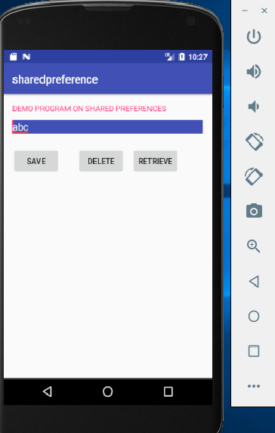

- How to save & restore data as Instance State
//XML FILE

<?xml version="1.0" encoding="utf-8"?>
<RelativeLayout xmlns:android="http://schemas.android.com/apk/res/android"
xmlns:tools="http://schemas.android.com/tools"
android:id="@+id/activity_main"
android:layout_width="match_parent"
android:layout_height="match_parent"
android:paddingBottom="@dimen/activity_vertical_margin"
android:paddingLeft="@dimen/activity_horizontal_margin"
android:paddingRight="@dimen/activity_horizontal_margin"
android:paddingTop="@dimen/activity_vertical_margin"
tools:context="nmit.instancestate.MainActivity">
<TextView
android:layout_width="wrap_content"
android:layout_height="wrap_content"
android:text="Hello World!" />
<EditText
android:id="@+id/name"
android:layout_marginTop="50dp"
android:layout_width="match_parent"
android:layout_height="wrap_content" />
<Button
android:id="@+id/submit"
android:layout_width="match_parent"
android:layout_height="wrap_content"
android:text="Submit"
android:onClick="display"
android:layout_marginTop="100dp"/>
<TextView
android:id="@+id/textDisplay"
android:layout_width="match_parent"
android:layout_height="wrap_content"
android:layout_marginTop="200dp"/>
</RelativeLayout>

JAVA FILE
package nmit.instancestate;
import android.support.v7.app.AppCompatActivity;
import android.os.Bundle;
import android.view.View;
import android.widget.EditText;
import android.widget.TextView;
import android.widget.Toast;
public class MainActivity extends AppCompatActivity {
EditText name;
TextView textDisplay;
private static final String KEY_FIRSTNAME="firstname_key";
@Override
protected void onCreate(Bundle savedInstanceState) {
super.onCreate(savedInstanceState);
setContentView(R.layout.activity_main);
name = (EditText) findViewById(R.id.name);
textDisplay = (TextView) findViewById(R.id.textDisplay);
if(savedInstanceState!=null){
String savedname = savedInstanceState.getString(KEY_FIRSTNAME);
textDisplay.setText(savedname);
}
else
Toast.makeText(this, "new entry", Toast.LENGTH_LONG).show();
}
public void onSaveInstanceState(Bundle savedInstanceState){
savedInstanceState.putString(KEY_FIRSTNAME, textDisplay.getText().toString());
super.onSaveInstanceState(savedInstanceState);
}
public void display (View v){
textDisplay.setText(name.getText().toString());
}
}

//OUTPUT
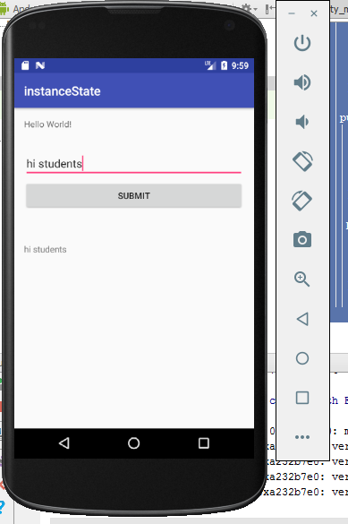
Before orientation
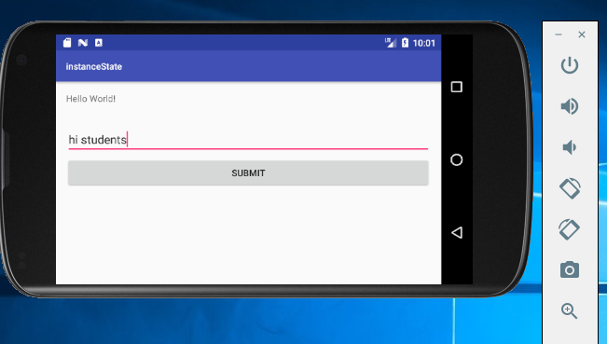
Before saving instance
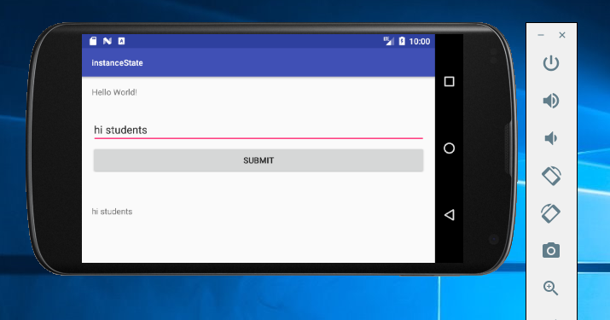
After saving instance

c.How to create and manage an SQLiteDatabase in Android.
d.How to insert, update, remove, and retrieve data from an SQLite Database.

Activity_main.xml

<?xml version="1.0" encoding="utf-8"?>
<RelativeLayout xmlns:android="http://schemas.android.com/apk/res/android"
xmlns:tools="http://schemas.android.com/tools"
android:id="@+id/activity_main"
android:layout_width="match_parent"
android:layout_height="match_parent"
android:paddingBottom="@dimen/activity_vertical_margin"
android:paddingLeft="@dimen/activity_horizontal_margin"
android:paddingRight="@dimen/activity_horizontal_margin"
android:paddingTop="@dimen/activity_vertical_margin"
tools:context="nmit.avika.MainActivity">
<TextView
android:layout_width="wrap_content"
android:layout_height="wrap_content"
android:text="Demo on SLQLITE"
android:textColor="@color/colorAccent"/>
<EditText
android:layout_width="match_parent"
android:layout_height="20dp"
android:id="@+id/etname"
android:hint="Enter Name"
android:background="#D3D3D3"
android:layout_marginTop="20dp"/>
<EditText
android:layout_width="match_parent"
android:layout_height="20dp"
android:id="@+id/etsalary"
android:hint="Enter Salary"
android:background="#D3D3D3"
android:layout_marginTop="60dp"/>
<Button
android:layout_width="60dp"
android:layout_height="20dp"
android:text="Insert"
android:id="@+id/btnInsert"
android:background="@color/colorPrimaryDark"
android:textColor="#ffffff"
android:layout_marginTop="120dp"
android:layout_centerHorizontal="true"
android:gravity="center"/>
<Button
android:layout_width="60dp"
android:layout_height="20dp"
android:text="Update"
android:id="@+id/btnUpdate"
android:background="@color/colorPrimaryDark"
android:textColor="#ffffff"
android:layout_below="@+id/btnInsert"
android:layout_centerHorizontal="true"
android:layout_marginTop="180dp"
android:gravity="center"/>
<Button
android:layout_width="60dp"
android:layout_height="20dp"
android:text="Select"
android:id="@+id/btnSelect"
android:background="@color/colorPrimaryDark"
android:textColor="#ffffff"
android:layout_marginTop="170dp"
android:layout_marginLeft="160dp"
android:layout_centerHorizontal="true"
android:gravity="center"/>
<Button
android:layout_width="60dp"
android:layout_height="20dp"
android:text="Delete"
android:id="@+id/btnDelete"
android:background="@color/colorPrimaryDark"
android:textColor="#ffffff"
android:gravity="center"
android:layout_alignParentBottom="true"
android:layout_alignStart="@+id/btnSelect"
android:layout_marginBottom="189dp" />
</RelativeLayout>

DbHelper.Java

package nmit.avika;
import android.content.ContentValues;
import android.content.Context;
import android.database.Cursor;
import android.database.sqlite.SQLiteDatabase;
import android.database.sqlite.SQLiteOpenHelper;
/**
* Created by user on 8/31/2018.
*/
public class DbHelper extends SQLiteOpenHelper {
private static String CREATE_TABLE1;
// Database name
static String DATABASE_NAME = "EmployeeRecords";
// Talble name
public static final String TABLE1_NAME = "employee";
// Fields for table
public static final String ID = "id";
public static final String NAME = "name";
public static final String SALARY = "salary";
// Required resorces to manage database
private ContentValues cValues;
private SQLiteDatabase dataBase = null;
private Cursor cursor;
public DbHelper(Context context) {
super(context, context.getExternalFilesDir(null).getAbsolutePath()
+ "/" + DATABASE_NAME, null, 1);}
@Override
public void onCreate(SQLiteDatabase db) {
CREATE_TABLE1 = "CREATE TABLE " + TABLE1_NAME + "(" + ID
+ " INTEGER PRIMARY KEY autoincrement, " + NAME
+ " TEXT, " + SALARY + " TEXT)";
db.execSQL(CREATE_TABLE1);
System.out
.println("Table is created...........................!");
}
@Override
public void onUpgrade(SQLiteDatabase db, int oldVersion, int newVersion) {
db.execSQL("DROP TABLE IF EXISTS " + TABLE1_NAME);
onCreate(db);
}
public void inserRecord(String name, String salary) {
dataBase = getWritableDatabase();
cValues = new ContentValues();
cValues.put(NAME, name);
cValues.put(SALARY, salary);
// insert data into database
dataBase.insert(TABLE1_NAME, null, cValues);
dataBase.close();
}
public boolean updateRecord(String name, String salary) {
dataBase = getWritableDatabase();
cValues = new ContentValues();
cValues.put(NAME, name);
cValues.put(SALARY, salary);
// Update data from database table
dataBase.update(DbHelper.TABLE1_NAME, cValues,null, null);
dataBase.close();
return true;
}
public Cursor selectRecords() {
dataBase = getReadableDatabase();
// Getting data from database table
cursor = dataBase.rawQuery("select * from " + TABLE1_NAME, null);
return cursor;
}
public void deleteRecord() {
dataBase = getWritableDatabase();
// Deleting all records from database table
dataBase.delete(TABLE1_NAME, null, null);
dataBase.close();
}
}

MainActivity.Java
package nmit.avika;
import android.support.v7.app.AppCompatActivity;
import android.os.Bundle;
import android.database.Cursor;
import android.view.View;
import android.widget.Button;
import android.widget.EditText;
import android.widget.Toast;
public class MainActivity extends AppCompatActivity implements View.OnClickListener {
private Button btnInsert, btnUpdate, btnSelect, btnDelete;
private DbHelper dbHelper;
private Cursor cursor;
private EditText etname,etsalary;
@Override
protected void onCreate(Bundle savedInstanceState) {
super.onCreate(savedInstanceState);
setContentView(R.layout.activity_main);
// Initializing Database
dbHelper = new DbHelper(getApplicationContext());
// Getting ids for all buttons
btnInsert = (Button) findViewById(R.id.btnInsert);
btnUpdate = (Button) findViewById(R.id.btnUpdate);
btnSelect = (Button) findViewById(R.id.btnSelect);
btnDelete = (Button) findViewById(R.id.btnDelete);
etname=(EditText)findViewById(R.id.etname);
etsalary=(EditText)findViewById(R.id.etsalary);
// Attaching listeners for all buttons
btnInsert.setOnClickListener(this);
btnUpdate.setOnClickListener(this);
btnSelect.setOnClickListener(this);
btnDelete.setOnClickListener(this);
etname.setOnClickListener(this);
etsalary.setOnClickListener(this);
}
@Override
public void onClick(View v) {
switch (v.getId()) {
case R.id.btnInsert:
String getname=etname.getText().toString();
String getid=etsalary.getText().toString();
dbHelper.inserRecord(getname,getid);
Toast.makeText(MainActivity.this,"Inserted Successfully!\n"+getname+"\n"+getid,Toast.LENGTH_SHORT).show();
//Toast.makeText(MainActivity.this,getid,Toast.LENGTH_LONG).show();
break;
case R.id.btnUpdate:
getname = etname.getText().toString();
getid = etsalary.getText().toString();
boolean isUpdate = dbHelper.updateRecord(getname,getid);
if (isUpdate == true)
Toast.makeText(MainActivity.this,"Record Updated Successfully..! \n" , Toast.LENGTH_LONG).show();
else
Toast.makeText(MainActivity.this, "Record Not Updated Successfully..! \n" , Toast.LENGTH_LONG).show();
break;
case R.id.btnSelect:
cursor = dbHelper.selectRecords();
if (cursor.moveToFirst()) {
do {
String strName = cursor.getString(cursor.getColumnIndex(DbHelper.NAME));
String strSalary = cursor.getString(cursor.getColumnIndex(DbHelper.SALARY));
Toast.makeText(MainActivity.this, "Values are \n Name :" + strName + "\n Salary :" + strSalary, Toast.LENGTH_LONG).show();
} while (cursor.moveToNext());
}
cursor.close();
break;
case R.id.btnDelete:
dbHelper.deleteRecord();
Toast.makeText(MainActivity.this, "Record Deleted Successfully..!", Toast.LENGTH_LONG).show();
break;
}
}
}

OUTPUT:




